MANGAUNG METROPOLITAN MUNICIPALITY
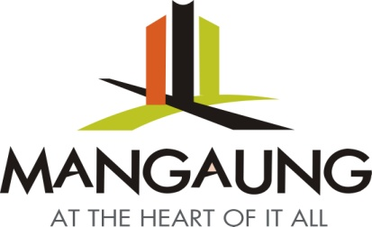
ADOPT – A – PARK APPLICATION FORM
Group / Organization Particulars
Name: ________________________________________________________________
Physical Address: ___________________________________________________________________________________________________________________________________________________________________________________________________________________________________________________
Phone Number: _____________________
E Mail Address: _____________________________________________________
Fax Number: ______________________
Area / Park Want to Adopt: ___________________________________________
___________________________________________

Signature: ___________________ Date: _____________________

Adoption Information ( For Office use only)

Assigned Park: ____________________________________________________________

Location: ___________________________________________________________________

Adoption Date : From : _______________________ To : _____________________________

Complete form and hand in at the Parks Offices situated in Zola Buddstreet , Willows or fax it to 051-4127011 or mail it to dawie.coetsee@mangaung.co.za

The following information is required and need to be submitted with the application form:

- Clear description of the area to be adopted/ apply for – street address/erf number
- Copy of identity document
- Written Proposal indicating how you want to contribute towards the Adopt -A-Park Program (DETAILED EXPLANATION OF WHAT YOU WANT TO DO AND FOR HOW LONG-1/2/3 YEARS)

