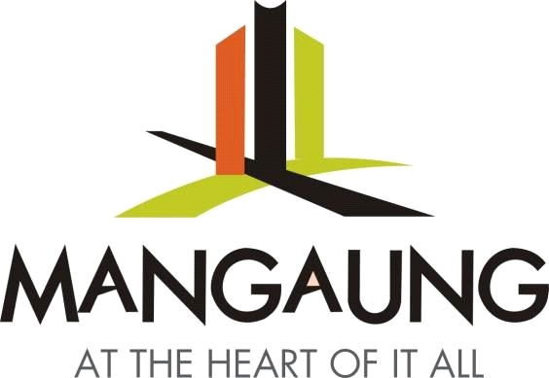
MANGAUNG METROPOLITAN

MUNICIPALITY

GENERAL TARIFFS

20
22
/2
3

–

202
4
/2
5

